Input paper: ENAV21-13.10

Input paper for the following Committee(s): check as appropriate Purpose of paper:
□ ARM □ ENG □ PAP X Input
X ENAV □ VTS □ Information

Agenda item (from agenda) 13
Workplan Task Number / Technical Domain 3.1.11/3.1
Working Group WG3
Author(s) / Submitter(s) Maritime and Port Authority of Singapore; Furuno Electric Co.; Tideland Signal Co. (contact Paul F Mueller paulm@tidelandsignal.com)

Singapore eRadar and eRacon Sea Trials August 2017

Summary
The Maritime and Port Authority of Singapore, together with Furuno Electric Co. and Tideland Signal Co., carried out joint sea trials for eRadar/eRacon performance evaluation. The trials took place in Singapore from 25 August to 31 August 2017.
The sea trials are extensions to the previous trials done in Denmark (EfficienSeas Project, 2011, Reference 2) and United Kingdom (ACCSEAS Project, 2013, Reference 2) followed by Singapore (2015, Reference 3).

Purpose
Recognizing the critical need for real-time, accurate, terrestrial-based positioning to complement GNSS positioning (Resilient PNT), especially in port and coastal areas, a joint project Team comprising of representatives from the Maritime and Port Authority of Singapore Hydrographic Department, Furuno Electric Co. and Tideland Signal Co. planned a new set of sea trials to build on the experience gained during the three previous trials.

Related documents
Please see References, below.

Background
Enhanced radar positioning is a proposal for a position fixing system in maritime navigation, based on radar navigation. It is the automation of the process of determining one’s own position by means of radar fixing, using a multitude of objects with known positions as reference points.
This trial uses three eRacons and one vessel fitted with an eRadar.
Compared to previous trials, the eRadar position determining algorithm has the following improvements:
a) The eRadar will automatically use two eRacons from the set of three for position solution. In the case that only one eRacon is available, the solution will use that eRacon only.
b) The eRadar will automatically compensate for latencies due to the motion of the vessel and the rotation of the antenna when calculating its position solution.

HOw eracons and eradars work
eRacons are essentially normal racons, modified to encode their position into the signal response to the radars that interrogated them. Position is encoded using FSK modulation in the leading dash of the racons’ Morse code response. The eRacon position is surveyed and entered as a static parameter in the eRacon configuration.
eRadar receivers detect this modulation and demodulate the position data. Knowing the azimuth and range of the eRacon target, and the heading of the vessel, the eRadar can then calculate and report the position for the vessel.

TRIAL ARRANGEMENT
Three locations for eRacons were chosen: RaconA (PSAB), RaconB (Raffles Lighthouse) and RaconC (Sakijang Beacon). The eRacons were deployed on existing aids to navigation as shown in Figure 1 below. All three eRacons are mounted at a high elevation in order to minimize the blockage and multipath effects seen in the previous Singapore trials.
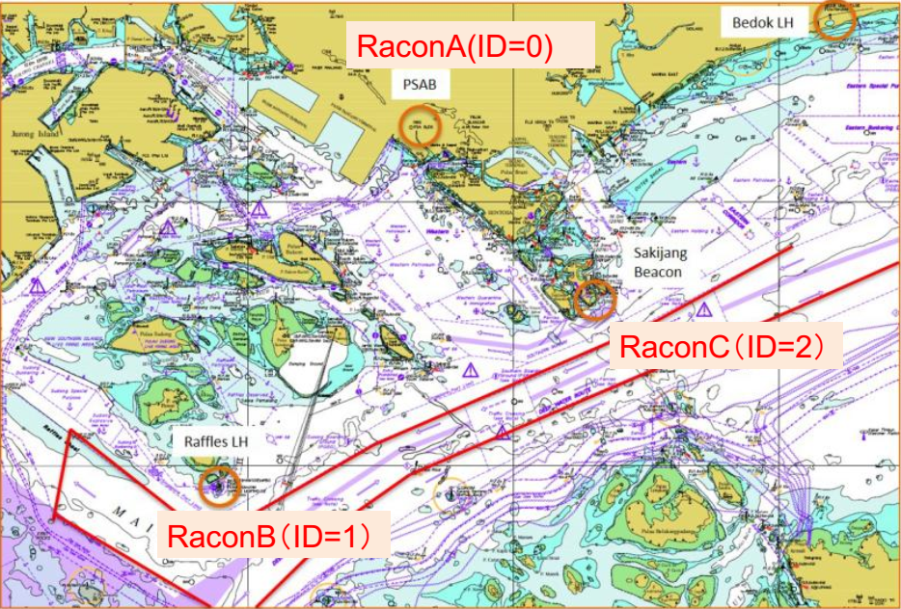
Figure 1 Sea trial area and locations of eRacons
There were three phases of trial:
- Static – this phase has the vessel unmoored and adrift, and was used to check out overall operation of the system. Results are tabulated below.
- Berth – this phase has the vessel tied up and still. As expected, this phase shows the highest accuracy. Results are tabulated below.
- Dynamic – this phase has the vessel sailing a known path compared to real-time kinematic satellite navigation system (RTX). This phase is discussed in detail below.

DISCUSSION
All phases of the trial worked well.

Dynamic Results
A sailing courses was chosen for Dynamic position solutions, as shown in Figure 2.
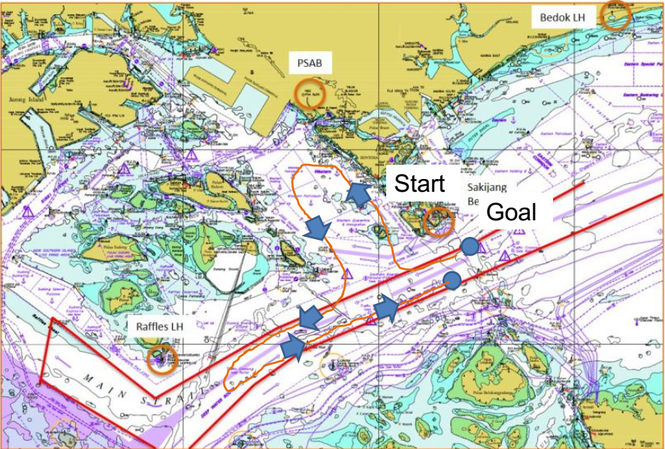
Figure 2 Dynamic Position Course
During the Static tests, the effects of horizontal dilution of precision were obvious. The errors were most pronounced in the area between Sakijang Beacon and Raffles Lighthouse. Figure 3 shows a plot of eRacon derived positions against GPS positions. Note the number of outliers at the southwest end of the track where horizontal dilution of precision has most effect.
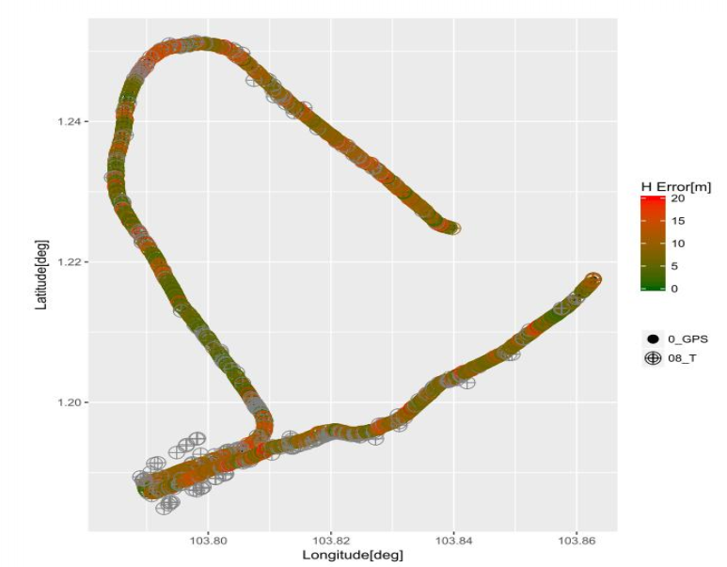
Figure 3 Results from Dynamic Course

Availability of eRacon Solutions
For each eRadar antenna scan there are four availability conditions: no eRacons, one eRacon, two eRacons and best available (e.g., either one or two eRacons). Availability is simply the ratio of solutions to scans.
There are various factors that determine availability:
- eRacon duty cycle (for these trials, the duty cycle is 100%)
- blocking by vessels or other objects
- multipath fading
- eRacon suppression due to a high number of radars (please see Reference 3 for a discussion of this problem)

Overall results
The following table illustrates horizontal error and availability for each of the trial phases:
 | One eRacon |  | Two eRacons |  | Best Available
Trial Phase | Horizontal Error (meters) | Availability (%) | Horizontal Error (meters) | Availability (%) | Horizontal Error (meters) | Availability (%)
Static | 37.5 | 86.7 | 11.9 | 61.9 | 16.5 | 86
Dynamic | 30.3 | 87.4 | 26.2 | 64 | 25.3 | 87.9
Berthing | 38.6 | 87.3 | 2.5 | 62.7 | 12 | 93.7
Table 1 Errors and Availability
Horizontal errors are compared to GNSS horizontal error of ± 2 meters.

Further Results
Other results and full data are available. Please contact one of the authors for further information.

Proposal to Establish a Permanent Test Site
The Maritime and Port Authority of Singapore is considering the establishment of a permanent test site in the Singapore Strait for an eRadar and eRacon system. The two main objectives are to
- Further assess of the reliability and accuracy of the system. The number of eRacons in the Strait will be selected so that at least three or more eRacons could be used to derive a position solution; and
- Encourage more ships to adopt and embrace this new positioning system as a complementary system to GNSS.

Standardization
It is the opinion of the authors that eRadar/eRacon is a viable complement to GNSS and should be considered as an element in Resilient PNT. Fitting radars and racons for eRadar/eRacon service can be done at low incremental cost at time of manufacture.
Standardization of the technique is required. Based on IALA success in AIS and VDES standardization, the authors believe the IALA would be a good venue for initial discussion on standardization.

References
- E-Navigation Underway, January 2012, Enhanced Radar Positioning as an e-Navigation Service, Jens K. Jensen, Danish Maritime Authority
- Radar Positioning - Trials results and feasibility analysis, IALA e-NAV14-9.7.1, Nick Ward, GLA
- ENAV19-13.12 Singapore eRadar eRacon Trial 19 October 2015

Action requested of the Committee
The Committee is requested to:
- Accept this paper for the information it contains.
- Consider adding eRadar/eRacon standardization to the work program following the 2018 IALA Conference.

