Input paper: ENAV20-13.11

Input paper for the following Committee(s): check as appropriate Purpose of paper:
□ ARM □ ENG □ PAP X Input
X ENAV □ VTS X Information

Agenda item 13
Technical Domain / Task Number Technical Domain 3 Shore technical infrastructure/3.1.11
Author(s) / Submitter(s) Maritime and Port Authority of Singapore; Furuno Electric Co.; Tideland Signal Co. (contact Paul F Mueller, paulm@tidelandsignal.com)

On Racons in Busy Harbours

Summary
Over the years there has been anecdotal evidence that racons perform poorly in busy harbours. The effects can range from limited response to no response, which can change over time due to vessel movement. During an eRadar/eRacon trial in Singapore in 2015 [1] the use of the eRacon in frequency agile mode (compared to fixed frequency mode) failed, further supporting the observation that racons can perform poorly in busy harbours.
To quantify this problem an experiment was designed to survey radar traffic. A test racon was made available to capture the survey data. Three causes of poor performance were identified. Due to time constraints for submitting this paper, the data has not been fully analysed for the three identified causes.
However, data analysis done for this paper already suggest three mitigation techniques that could improve the performance of racons in busy harbours. The mitigation techniques are discussed in the Conclusions section.

Background
The authors propose the following three most likely causes of poor racon performance in busy harbours:
- Racons are too busy to respond to all pulses
A racon requires some amount of time to process and transmit its response and also has other processing that must be completed before the racon can receive and respond to a new pulse. The model of racon used for the test racon requires 100 microseconds for normal reception, processing, response, and transmitter and power supply recovery for each pulse received (or, in other words, this racon can process 10,000 pulses per second). During this time, the racon cannot receive or respond to radar pulses.
- Racon Side Lobe Suppression (SLS) masks some radars
All radar antennas are imperfect to some extent. They can radiate detectable amounts of power at other angles than the “main lobe” of the antenna. It is undesirable for a racon to respond to anything but the main lobe, because the extraneous responses can clutter the radar display and confuse an operator. Racons are designed to suppress responses to “side lobes” of antennas (SLS) (please see Annex 1 for illustrations of side lobes as seen by a racon). SLS works by identifying a signature for each radar. Frequency and Pulse Width are typically used for identification. Racons respond only to the strongest signals from identified radars, typically within 10dB of the strongest signal. When there are two or more radars with the same signature, it is likely that only one of the radars will be responded to, and the others will not. The radar that is responded to will change as ships move about and signal strength at the racon changes.
- Physical blockage
There are ships or other objects between some radars and racons blocking transmission. The affect would be less likely with higher radar and racon elevations. However, over longer distances, the effect of higher elevations becomes less advantageous.

Discussion
A survey device was constructed by modifying a production racon to act as receive-only and to transfer measured pulse data at high speed to a capture device for storage and later analysis.
Data captured includes frequency, pulse width, amplitude (signal strength) and time stamp for each pulse received. An insignificant number of very weak Sband pulses were received and Sband is not included in this paper.
The test racon has an Xband signal sensitivity or threshold of about -53 dBm and uses a 6 dBi gain antenna. Frequency measurement resolution is about 0.3 MHz and pulse width resolution is 25 nanoseconds. Please note that the test racon requires 4.3 microseconds to receive and process each pulse and that some pulses may have been lost.
Two survey locations were chosen in the Port of Singapore: Raffles Lighthouse and Cyrene Beacon. Data was collected mid-day (11:00 – 14:00) 17 February 2017. The choice of a tall lighthouse and a shorter beacon is to help test for the physical blockage effect.
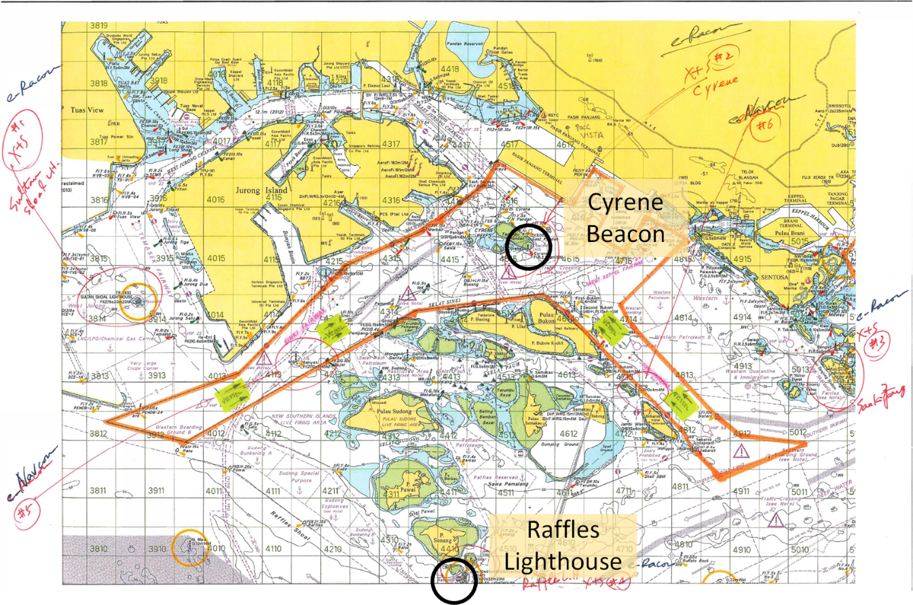
Figure 1 Singapore Harbour
In a busy harbor a large amount of radar data can be captured quickly. The capture device would run for about 9.5 minutes before being saturated. The capture device data was downloaded to a computer disk drive. A number of 9.5-minute data sets were captured, per the following table:
Table 1 Data Set Description
Location | Number of Data Sets | Total Capture Time | Total Number of Data Points
Raffles | 4 | 39 Minutes | 36,000,000
Cyrene | 2 | 19 Minutes | 18,000,000

Initial Findings

Data Rate
From Table 1 data, the average capture rate was calculated to be on the order of 16,000 pulses per second. Compare to the test racon normal maximum operating rate of 10,000 pulses per second. This implies that in normal operation about 38% of the radar pulses would be lost.
This is the first conclusion: many pulses are blocked from reception because the racon is too busy to handle them.

Frequency Histograms
Band usage is analysed. A typical data set from Raffles is shown first:
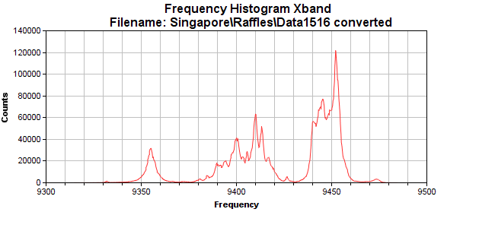
Figure 2 Raffles Data Frequency Histogram
This graph shows actual usage of the band from about 9330 MHz to about 9475 MHz. Each peak represents at least one radar. Smaller peaks represent either fewer radars at the frequency or radars farther away (a far-away radar has lower signal strength and fewer pulses are detected). Larger peaks represent either many radars at the frequency, or radars close-in (a close-in radar has higher signal strength and more pulses, including side lobes, that exceed the threshold).
Compare the Raffles graph to the following graph from Cyrene data:
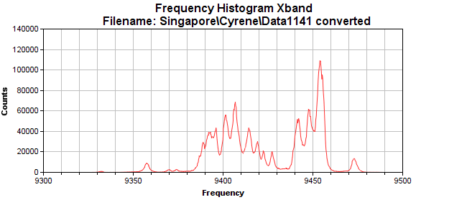
Figure 3 Cyrene Data Frequency Histogram
The graph looks similar to Raffles and many of the peaks are at the same frequency. Note that the peak at about 9355 MHz is now very small. The vessel with that radar may have been very close to Raffles when the data was captured.
Note also the very large, broad peaks in both graphs at about 9450 MHz. One of the authors has indicated that one radar manufacturer sold a large number of magnetron radars at 9450 MHZ and this broad peak could represent many of these popular radars.
This is the second conclusion: radar frequencies seem to be clumped around a very few frequencies. There is more available bandwidth than is being used.

Frequency and Pulse Width Histograms
By applying 3D histograms in both frequency and pulse width, we can begin to resolve a number of separate radars. Graphs are shown following:

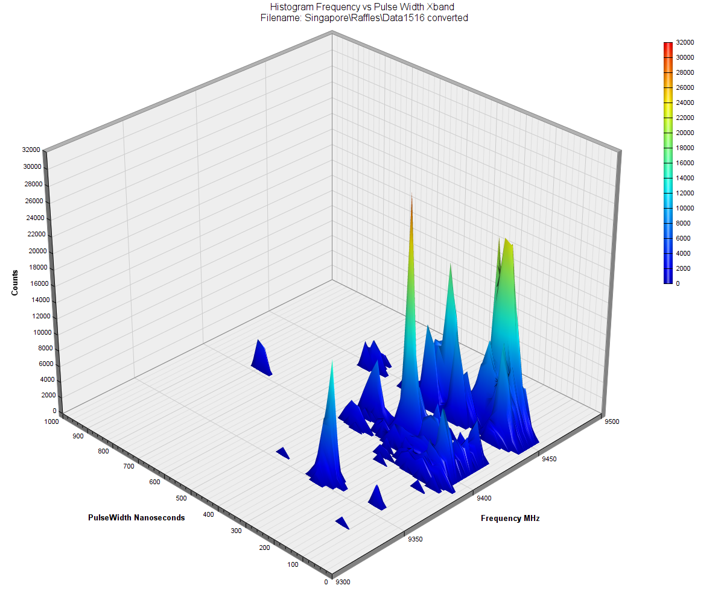
Figure 4 Raffles Data Frequency and Pulse Width Histogram
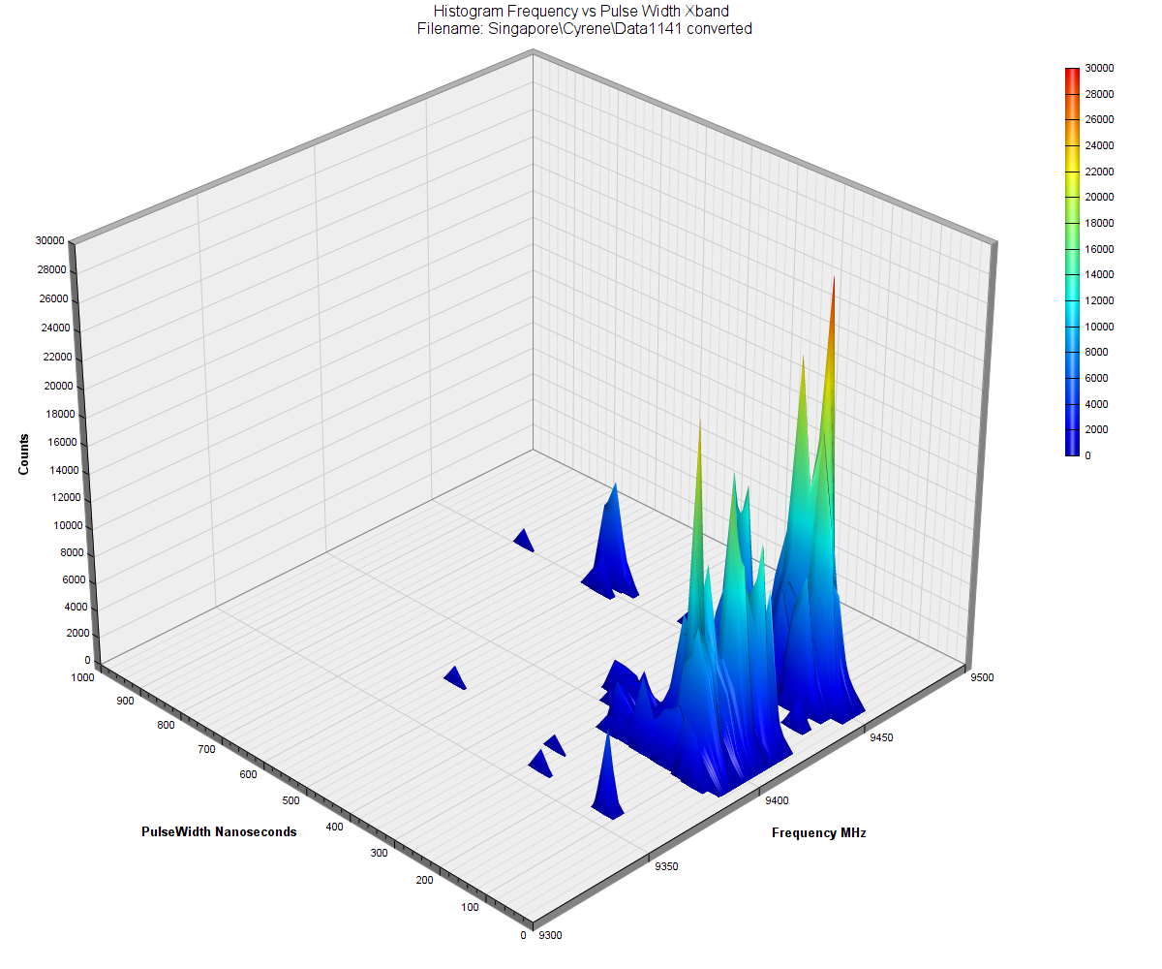
Figure 5 Cyrene Data Frequency and Pulse Width Histogram
Again, the higher peaks may imply a number of radars at that frequency and pulse width.

Peak Detection
To help identify the number of radars, a peak detection algorithm was used on the frequency and pulse width histogram data. The assumption is that each peak represents (at least) a single radar. Results of peak detection give the following graphs:
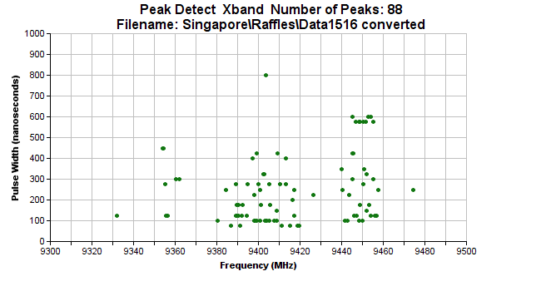
Figure 6 Raffles Data Peak Detection
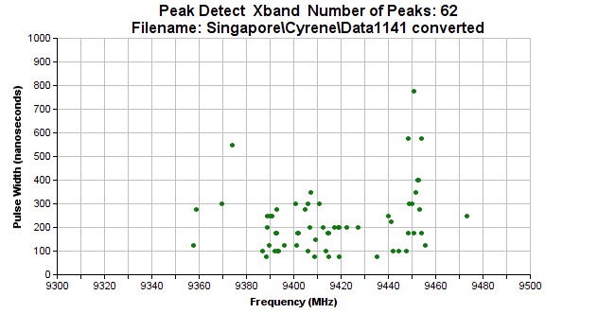
Figure 7 Cyrene Data Peak Detection
The higher number of radars visible at Raffles (88 vs 62) may indicate that elevation can improve service. But because the number of vessels and their distribution in port are not known, the authors judge this to be inconclusive.
A note on pulse width: For all radars, when the display range setting is increased, the radar increases the signal pulse width in order to receive enough energy from the farther targets for good detection. Typical ship radars do not use pulse widths longer than about 1000 nanoseconds. Weather radars, surveillance radars and aircraft radars may use longer pulse widths.

Amplitude over Time
To further resolve a number of radars, analysis of amplitude over time for a given signature can be used. Radar antennas have fixed (but relatively unknown) rotation periods of about three seconds. With a suitable time interval choice, the time stamped amplitude data can be used to help resolve multiple radars.
The following chart shows a single data set at one frequency and pulse width signature; at this time interval, the data seems to be unreadable:
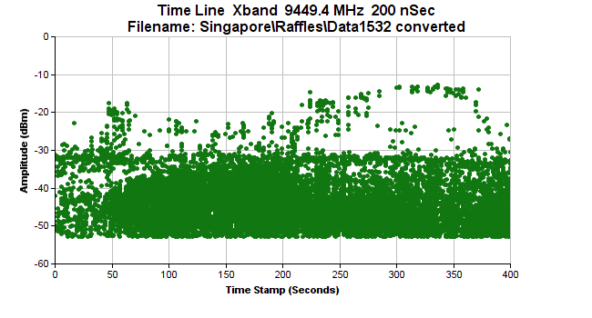
Figure 8 Raffles Data Amplitude vs Time
However, by expanding the time scale, we can clearly see one radar with an antenna period of about 2.6 seconds:

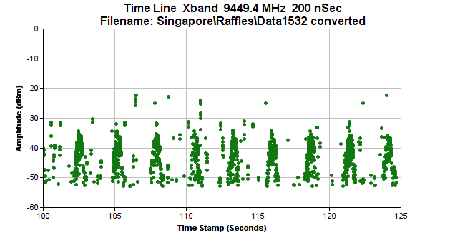
Figure 9 Raffles Data Expanded Amplitude vs Time
The human eyes and brain combination is expert at identifying patterns in data. The above graph shows a hint of another radar at about a two second period and yet another hint at about four seconds. Unfortunately at this signature, SLS processing of the rare but stronger signals from the four-second radar will block the more obvious radar.
Here is expanded data at a different signature that may be showing us three radars. There are similar SLS problem as the previous data set:
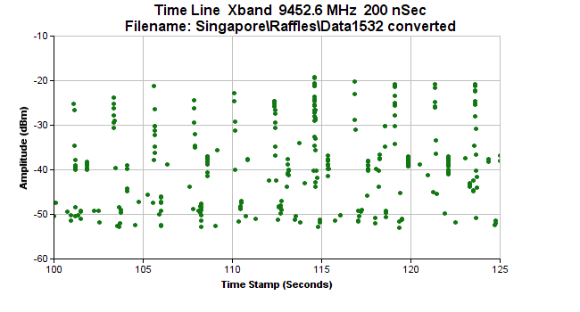
Figure 10 Raffles Data Expanded Amplitude Vs Time, Different Signature
This is the third conclusion: there appear to be a relatively large number of radars with the same signature. This will cause SLS to fail at that frequency and pulse width.

Further Analysis
Analysis done so far has been in support for Cause 1, regarding racon busy, and Cause 2, regarding SLS.
Further analysis may lead to more insight.
- Apply time stamp and amplitude analysis to all peaks to better estimate how many radars are in the data sets.
- Process the data to estimate how many identifiable radars would be blocked by SLS
Further analysis cannot be done for Cause 3 because port and vessel data is not available.

Conclusions
The first conclusion is that many radar pulses can be blocked because racons are too busy to receive and process them (Cause 1). One mitigation technique would be for racon manufacturers to improve processing and recovery times for racons. There is a limit: the racon cannot receive a new pulse while it is transmitting. Transmit times can be from 5 to 60 or more microseconds.
The second conclusion is that radar frequencies seem to be clumped around a small number of frequencies and the third conclusion is there may be many radars at the same frequency. The second and third conclusions support Cause 2 regarding SLS. Two mitigation techniques would be for radar manufacturers to: a) use more of the frequencies within the band, and b) avoid repeatedly using the same frequency on a large number of units.
There is no conclusion for Cause 3 because needed port and vessel data are not available.
Overall, the survey was quite successful. Although time constraints limited the amount of analysis that could be presented in this paper, significant conclusions were reached and mitigation techniques were suggested. It is the intention of the authors to complete the analyses for a future paper.

References
- ENAV19-13.12 Singapore eRadar eRacon Trial 19 October 2015

Action requested of the Committee
The Committee is requested to:
- Please accept this paper for the information that it provides.
- Please consider whether the effects described by this paper should be studied further by the Committee.
- Please consider whether the effects described by this paper would be of interest to other Committees and liaise accordingly.
- Please consider whether the effects described by this paper would be of interest to other bodies and liaise accordingly. In particular the conclusions on frequency usage and the suggested mitigation techniques described might be of interest to CIRM.

Annex 1 Example of radar antenna SIDE lobeS
The following time line graphs are from a single radar. Note that in both graphs, the main lobes of the radar antenna are clearly identifiable (approximately -12 dBm at about 21.7, 24.2, 26.6 and 29.1 seconds). Please also note the lobes from the back of the antenna (approximately -37 dBm, near 23, 25.4 and 27.8 seconds). Without side lobe suppression (SLS), racons would respond to these back lobe pulses and the radar display would show two locations for the racon on opposite side of the vessel.
The second graph more clearly shows side lobes from the antenna (approximately -37 dBm), one set located at about 23.8 and 24.5 seconds. Again, without SLS, the racon response to these lobes would cause false images of the racon to be displayed by the radar. The images would be displayed at about ±50 degrees from the main lobe.
For all of these lobes, an SLS setting of at least 20 dB would prevent the racon from responding.
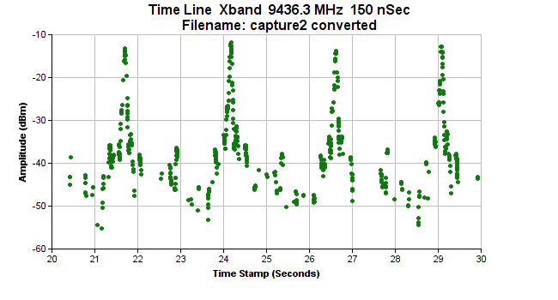
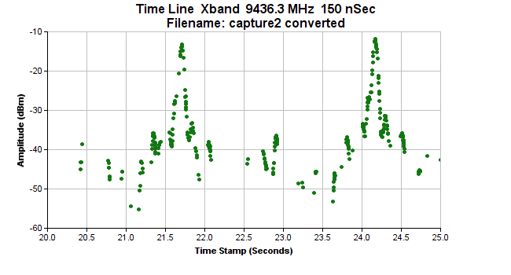

Input document number, to be assigned by the Committee Secretary

